2024 POPASMOKE REUNION
SILENT AUCTION

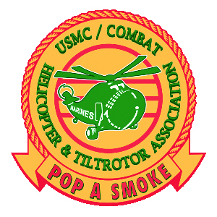

All proceeds support the POPASSMOKE Scholarship Program.
Donations can be delivered upon arrival at the Sheraton Pentagon City or sent to:

POPASMOKE
C/O SLJO Rachel Orgel
4118 Aspen St
Chevy Chase, MD 20815

Tax Deduction- The USMC/Combat Helicopter Association is a 501(c)3 charitable organization, and donated items are tax deductible to the extent allowed by the IRS.
Receipts will be provided upon request.

Please provide the following for all items donated

Item Description: ____________________________

Item Value: $___________________________

Donor’s name: ____________________________

Donor’s address: ____________________________

____________________________

____________________________

